Assessing Flooding and Hydrodynamics for Community Preparedness and Revitalization in the historic Tanyard neighbourhood, Pensacola, Florida
Jaap Nienhuis, Florida State University, Tallahassee, FL

Problem assessment
The historic neighborhood in Pensacola is frequently flooded. The neighborhood is a historic district that was inhabited long before development of modern storm drainage. That makes it unlikely the Tanyard originally experienced the frequency and intensity of flooding it does now. It is currently a FEMA Flood Hazard Area.
Residents report flooding is caused by intense rainfall. An assessment by NOAA indicates that sea-level rise is unlikely to independently cause flooding in downtown Pensacola (Fig. 1). Similarly, Tanyard flooding during tropical cyclones are more likely caused by extreme rainfall than storm surge, based on predictions from NOAA (Fig. 2).
Frequent summer rains overflow the storm drains. Sewer overflows have also been observed during storms, likely caused by storm water inflow into the sanitary sewer system through illicit connections.
Tanyard flooding is worsened during high tides in the Pensacola Bay. This makes flooding likely caused by a combination of insufficient storm drain capacity into Pensacola Bay (e.g. pipe diameter) as well as insufficient water level head in a gravity driven system (e.g. grades of the pipes).

Future change
It is important to note that Tanyard flooding will be exacerbated by sea-level rise. Even though assessments by NOAA indicate that sea-level rise or storm surge induced flooding is not a major concern by itself, elevated sea-level will worsen the Tanyard flooding because rainfall will not be able to drain into Pensacola Bay. Additionally, climate change will lead to an increase in the intensity and occurrence of extreme rainfall events.

Effectiveness of the Government Street Regional Stormwater Pond
As a potential solution to flooding in the Tanyard, the city of Pensacola developed the Government Street Regional Stormwater Pond at Corrine Jones Park. However, reports from residents indicate the retention pond has not been able to overcome flooding and that the retention pond does not drain sufficiently in between storm events.
Analysis of the engineering drawings of the retention pond show that a large part of the Tanyard neighborhood, mostly east of Coyle Street and south of Intendencia, continues to drain to the existing 84” storm pipes rather than being connected to the retention pond (see drawing attached). This part of the neighborhood continues to drain south into the Bay through existing storm drains, with insufficient grade or diameter to accommodate the flow during storms.

Potential solutions
A proposed check valve between the bay and the storm drain is unlikely to be a solution because the flooding is not caused by high tide, but by rainfall during high tide. Preventing the inflow of Bay water into the storm drain would not increase outflow during storms.
Potential solutions are the installation of pumps, the expansion of retention ponds that can drain to bay under sufficient grade (potentially during low tide) and/or the elimination of illicit connections to prevent storm water inflow into the sanitary sewer.

Future plans
The analysis can be greatly improved through more accurate mapping of the flood extent during storms, ideally accompanied by measures of rainfall intensity and tidal conditions in the Bay.

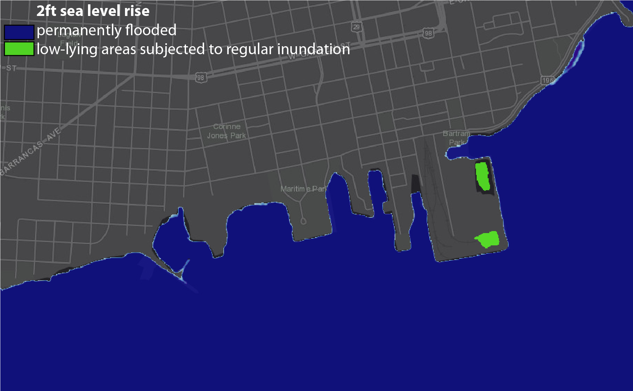
Figure 1. NOAA Assessment of sea-level rise hazards to downtown Pensacola and the Tanyard neighborhood, subjected to 2 ft (likely by 2100AD) sea level rise. Retrieved from: https://coast.noaa.gov/slr

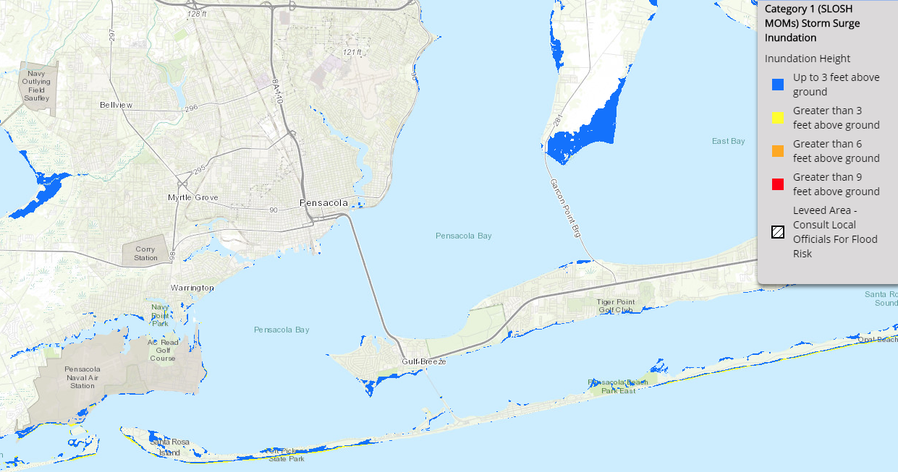
Figure 2. Maximum storm surge inundation in Pensacola estimated for cat. 1 hurricane winds. Retrieved from: https://www.nhc.noaa.gov/nationalsurge/

Resources:
- Climate change leads to more extreme weather
https://nca2014.globalchange.gov/highlights/report-findings/extreme-weather
- Precipitation Extremes Under Climate Change
O’Gorman, P.A. Curr Clim Change Rep (2015) 1: 49. https://doi.org/10.1007/s40641-015-0009-3
- FEMA Floodmaps
https://msc.fema.gov/portal/home
- Historic map of downtown Pensacola
http://wp.studeri.org/2014/10/helping-washerwomans-creek-find-daylight/

